Exercise 1 (Worth 2%) **CPAN133- “Operating Systems”**

**Name: ID:**

**Section**

Exercise 1 – Basic commands in Unix

**Due Date – January 11 (end of the class time), 2022**

**TASK 1:** Take snapshots and attached here.

REMOTELY CONNECTING TO THE SERVER (USING SSH)

* **For Windows :**
  + *PUTTY:* [*Download page*](https://www.chiark.greenend.org.uk/~sgtatham/putty/latest.html)*(recommended)*

You can also use other applications:

* + [***Mobaxterm***](https://mobaxterm.mobatek.net/download-home-edition.html)
  + [***SSH secure shell***](https://softdeluxe.com/SSH-Secure-Shell-204309/download/)

After downloading follow the following steps:

* Host name: munro.humber.ca
* port: 22
* Enter your username starts with "n" for example- "n01527728"
* Enter your password
* **For Mac OS :**
* *Terminal : ssh* [***username****@munro.humber.ca*](mailto:username@munro.humber.ca)
  + - *Here replace username with your actual username.*

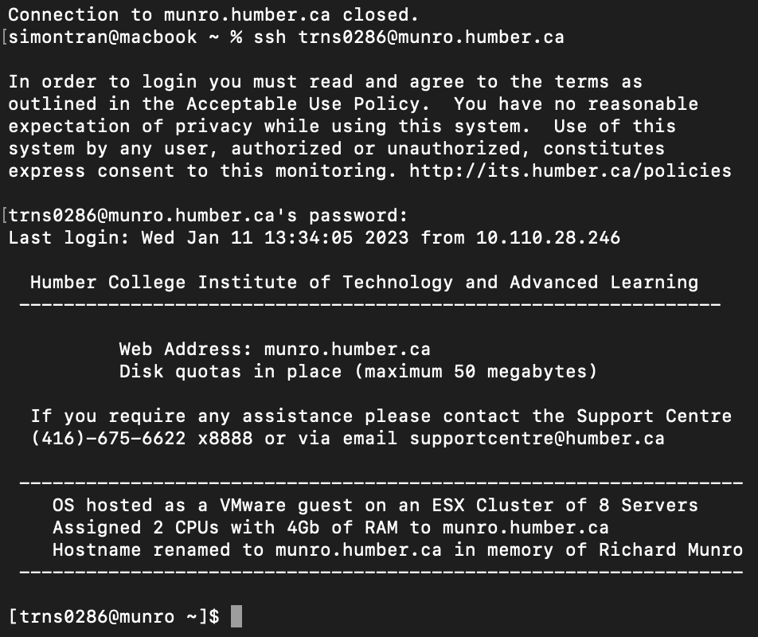

**TASK 2:** Write the answers and submit by editing this document.

PRACTICE WITH BASIC UNIX COMMANDS

1. *The* ***date*** *command (Display the system date)*

* + Type **date** in the command line and press **Enter**
    - What do you notice?

A: The current date and time is outputted in the current location’s timezone.

* + Type **Date** in the command line and press **Enter**
    - What do you notice?

A: An error occurs saying “command not found”, because commands are case sensitive and Date is not a command in the terminal.

* + Try options **(u, s)**
    - **“-s” option is used to set the time. If you try to do this it will not work. What do you think why we can't set the time?**

A: When the -u option is used, it shows current date and time in the coordinated universal time. When the -s option is used to attempt changing the date, a message is outputted stating “Operation is not permitted”. This is likely due to a lack of privileges.

1. *The* ***cal*** *command (Display the calendar)*
   * Type **cal** in the command line and press **Enter**
     + What do you notice?

A: When cal is inputted, we see a visual display of the current month in calendar form, with the current date highlighted.

* + Type **cal 7 1776**

A: When this is inputted, we see a visual display of July 1776 in calendar form.

* + Try option**(m,y)**

A: When the -m option is used, we see a visual display of the current month in calendar form, with the current date highlighted. When the -y option is used, we see a visual display of all months of the current year in calendar form.

1. *The* ***whoami*** *command (Shows who is logged into the server)*
   * Type **whoami** in the command line and press **Enter**
     + What do you notice?

A: When “whoami” command is used, it outputs the current user’s username.

1. *The* ***clear*** *command (clears the screen)*

Type **clear** in the command line and press **Enter**

**

o What do you notice?

A: When the “clear” command is used, it creates enough line breaks so that all previous inputs and outputs are no longer in view. The size of the window will determine the number of line breaks.

1. *The* ***whatis*** *command (a brief description of a command)*

Type **whatis who** in the command line and press **Enter**



o What do you notice?

A: When “whatis who” is inputted, it shows an explanation of the “who” command. It explains that the “who” command shows who is logged on and displays who is on the system.

1. *The* ***exit*** *or* ***logout*** *command (Exits when a GUI is not used)*

o What do you notice?

A: When the “exit” or “logout” command is used, it exits/logs out the user from the secure shell.

**Submission instructions:**

You have to submit your exercise within class time. No late submission will be accepted. After answering all the questions submit this .doc file through the blackboard. The link is under the course documents->exercises->exercise1.